QUIZ RESULTS
MODULE4: DIMENSIONALITY REDUCTION

No. | Quiz title | Completion Status | Score | Coursera link
1 | Module4_1_Dimensionality Reduction | Completed | 100% | Quiz 1
2 | Module4_2_Module 4 Quiz | Completed | 100% | Quiz 2

Module4_1_Dimensionality Reduction
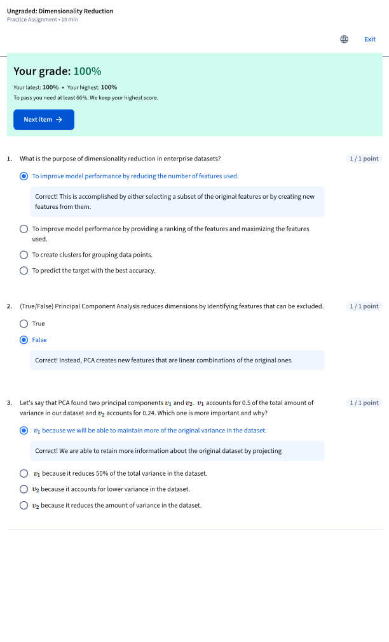

Module4_2_Module 4 Quiz

